**Informatics - The next step** Karan Goda | 460496371

*Informatics: The collection, classification, storage, retrieval and analysis of data.*



**Utility of Informatics**

An organization may have ample data, however without informatics, it cannot be interpreted as meaningful information. The organization can apply data mining methods and tools to generate meaningful results. These results ultimately help in the process of creating visual graphs such as a line graph in order to extrapolate and obtain results on the target problem.

**Importance to you**

Your organization may have many goals and ideas, however without doing research, the organization has lesser chances to succeed. Informatics does not guarantee that your organization will succeed, however it will provide interpretable information which will help in forming a bias on whether to execute a plan in the organization or not.

**Informatics**

*Advantages*

1. Unorganized data is given meaning.
2. Informatics can be applied to almost any field.
3. An objective without a goal or research can be very deadly.

*Disadvantages*

1. Gathering data is an expensive process.
2. Informatics and analysis is costly
3. Analysis is not an autonomous process.

**Graphs**

**Fields that Informatics is useful in**

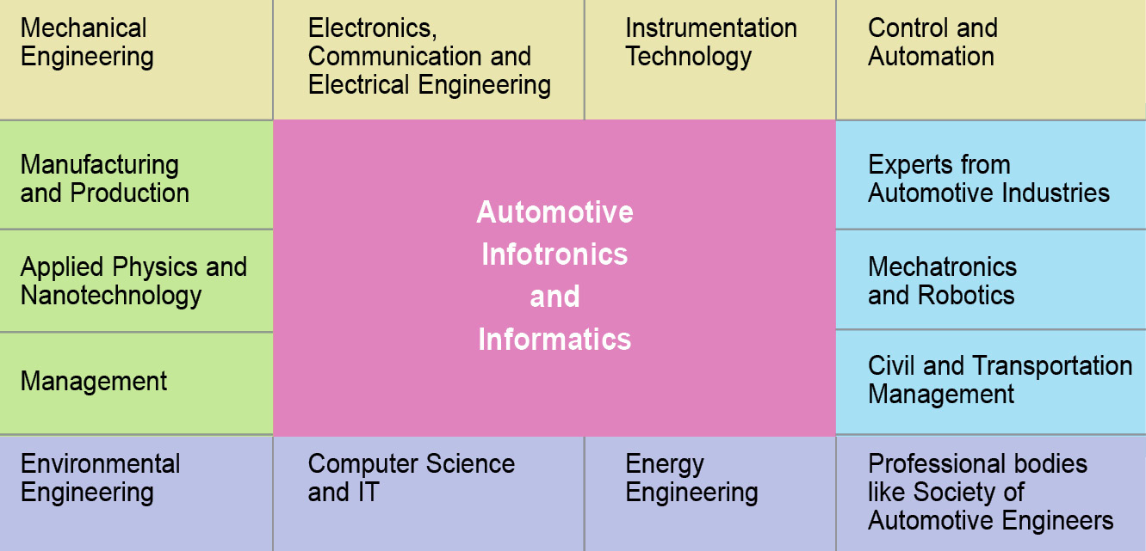

Fields Informatics is beneficial in

**Data Mining Methods**



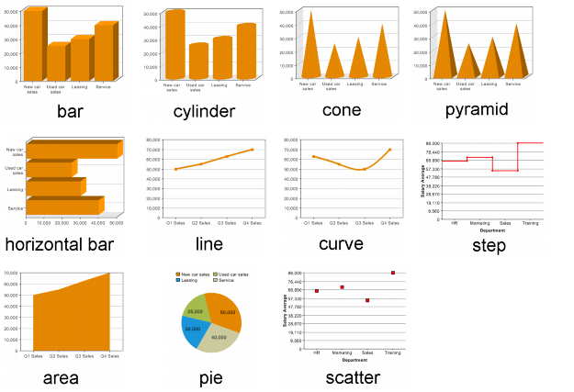

*Types of visual interpretations of information*

*Tools that help in Informatics*

* R Studio
* Unix
* Jupyter Notebook Python module
* Excel
* SQL
* Many others!